
RAMAIAH
Institute of Technology
USN | 1 | M | S

(Autonomous Institute, Affiliated to VTU)
(Approved by AICTE, New Delhi & Govt. of Karnataka) Accredited by NBA & NAAC with ‘A’ Grade

SEMESTER END EXAMINATIONS – MAY/JUNE 2018

Course & Branch | : | B.E. : Computer Science and Engineering | Semester | : | IV
Subject | : | Design and Analysis of Algorithm | Max. Marks | : | 100
Subject Code | : | CS42/CS1542 | Duration | : | 3 Hrs

Instructions to the Candidates:
- Answer one full question from each unit.

 |  | UNIT- I
1. | a) | Identify the stable matching set of men and women for the following preference list. | CO1 | (08)
  Men’s Preference List |  |  |  |  |  | Women’s Preference List
   | 1 | 2 | 3 | 4 |  |  | 1 | 2 | 3 | 4
  A | W | X | Y | Z |  | W | D | C | B | A
  B | W | X | Y | Z |  | X | D | C | B | A
  C | W | X | Y | Z |  | Y | D | C | B | A
  D | W | X | Y | Z |  | Z | D | C | B | A
 | b) | Illustrate the Competitive facility location problem with an example. | CO1 | (04)
 | c) | Prove that “Consider an execution of the G-S algorithm that returns a set of pairs S. The set S is a stable matching. | CO1 | (08)
2. | a) | Design an algorithm to find stable matching for a given ‘n’ men & ‘n’ women set. State the real world example for such algorithm. | CO1 | (06)
 | b) | Illustrate whether the following statements are true or false. Give justification.  [O – Big Oh, Θ – Big Theta, Ω - Big Omega ]  - n(n + 1)/2 Є O(n^2)  - n(n + 1)/2 Є Θ(n^2)  - n(n + 1)/2 Є Ω(n^2) | CO1 | (06)
 | c) | For the following set of problems, write the algorithm and specify the running time.  - Find the pair of points that are closest together in a plane consisting of n points, each specified by (x, y) coordinates.  - Find an independent set of maximum size for a given graph. | CO1 | (08)
 |  | UNIT- II
3. | a) | Outline DFS and BFS algorithm and their its worst case efficiency when graph is given by adjacency list representation. | CO2 | (08)
 | b) | Design a Merge Sort algorithm for sorting numbers using divide and conquer method. Apply the same algorithm to sort the list {11,6,12,5,14,22,2,4,17,1} and count the number of inversions. | CO2 | (08)
 | c) | Prove that let T be a BFS tree, let x and y be nodes in T belonging to layers Li and Lj respectively, and let (x,y) be an edge of G. Then I & j differ by at most 1. | CO2 | (04)
4. | a) | Explain the below approaches to solve recurrences:  - Unrolling the Mergesort recurrence  - Compute the topological ordering for the following graph.  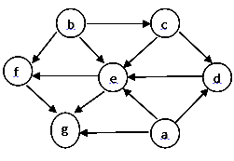 | CO2 | (07)
 | b) | Prove that if graph G has a topological ordering, then G is a DAG. | CO2 | (05)
 | c) | For the given graph construct the DFS and BFS traversal using the source A. Is the given graph a bipartite?  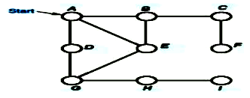 | CO2 | (08)
 |  | UNIT- III
5. | a) | Design the greedy algorithm for Interval Scheduling with its running time. | CO4 | (06)
 | b) | Design Kruskal’s algorithm to find Minimum Spanning Tree. Apply the same for the following graph.  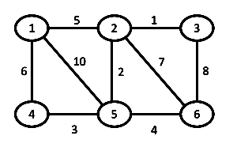 | CO4 | (08)
 | c) | Using Huffman coding, find the average code word length for the following table. | CO4 | (06)
  Character | A | B | C | D | E | F
  Frequency | 4 | 5 | 3 | 6 | 8 | 10
6. | a) | Design an algorithm for finding a single source shortest path for a given graph. Apply the same for the following graph. Assume “a” as the source vertex.  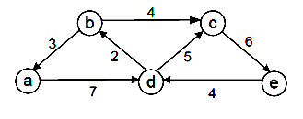 | CO4 | (10)
 | b) | Prove that “Greedy algorithm for interval scheduling returns an optimal set A”. | CO4 | (06)
 | c) | Prove that “Prim’s Algorithm produces a minimum spanning tree of G”. | CO4 | (04)
 |  | UNIT- IV
7. | a) | Write the Bellman Ford Algorithm. Apply the same for the following graph to find the shortest path. Assume node “S” as the starting vertex.  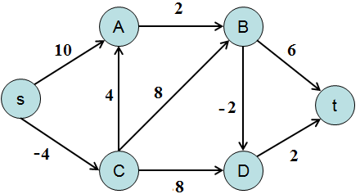 | CO4 | (08)
 | b) | Define the following with respect to Ford-Fulkerson Algorithm:  - Residual Graph ii. Augmenting Path iii. Reverse Edge. | CO4 | (06)
 | c) | Solve the following weighted interval scheduling problem using memoization technique. | CO4 | (06)
  Interval | 1 | 2 | 3 | 4 | 5
  Start | 3 | 10 | 16 | 13 | 19
  Finish | 11 | 15 | 17 | 20 | 25
  Weight | 5 | 4 | 3 | 1 | 1
8. | a) | Demonstrate the Ford-Fulkerson algorithm to find the maximum flow in the given graph.  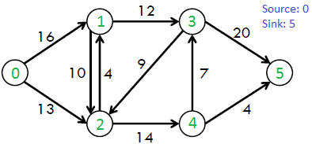 | CO4 | (08)
 | b) | Write the Knapsack algorithm. Mention the recurrence relation for the Knapsack problem. | CO4 | (06)
 | c) | Describe the following:  - Airline Scheduling ii. Survey Design. | CO4 | (06)
 |  | UNIT- V
9. | a) | What do you mean by polynomial time reduction? Give a correlation between vertex-cover and independent set problem. | CO5 | (10)
 | b) | Discuss Travelling salesman problem. Justify that travelling salesman problem is NP-Complete. | CO5 | (10)
10. | a) | Discuss circuit satisfiability problem and prove that it is NP-Complete. | CO5 | (10)
 | b) | Compute Hamiltonian cycle for the following graph. How can we prove that TSP is complete using Hamiltonian cycle problem?  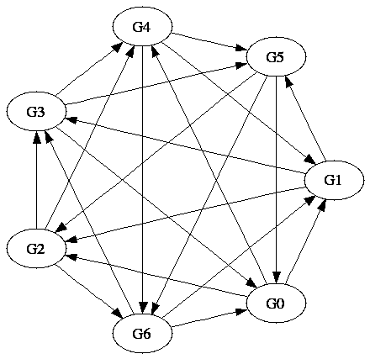 | CO5 | (10)

****************

